ASSIGNMENT # 3 – TRAINING AN LLM

Part I:
- Think of a dataset (corpus) and a classification task. Ideally, both the corpus and the classification task can be used in your final paper. However, it’s OK if you do this for the assignment (you will still need a corpus). You can choose any task except sentiment classification.
Please see my GitHub for Assignment #3:
https://github.com/smurphyphd/text-analysis-public-university-llm/tree/main
The GitHub folder Assignment 3 contains the excel file I used to build my dataset and classify the data myself. This excel file, called “trainingdataset_ontario_budgets_v4_llm_sample”.xlsx, contains 202 observations. Each observation represents a paragraph from the introduction section of the operating budget of an Ontario university in advance of an academic year. My current sample contains operating budgets from Queen’s University and University of Toronto between 2017 and 2023. I selected this as an initial sample as Queen’s and UofT at times have had opposing financial results and leadership approaches to market conditions.
In 2019, the Ontario government imposed restrictions on domestic tuition fees, which some Ontario universities have attributed as the cause of poor financial performance post-2019. I am interested in how publicly funded universities in Canada talk about how dependent they are upon their provincial government. I want to see if there are differences in how these organizations perceive the external market and their place within it and if those differences are correlated with differences in financial results incurred t+1. I am choosing to analyze the introduction section of the operating budget of each Ontario university, created in advance of the academic school years pre and post 2019. These introduction sections, sometimes called “setting the context” or “the changing financial landscape”, outline the university’s perspective on its market conditions, the policy decisions of its provincial and national government, and how financially vulnerable or adaptable is their institution.
- Decide the number of categories that you will be predicting.
Academic Definition: Resource Dependence
Emerson (1962) argued that power resides implicitly in one’s resource dependence on the other in a relationship. The dependence of actor A upon actor B is (1) directly proportional to A's motivational investment in goals mediated by B, and (2) inversely proportional to the availability of those goals to A outside of the A-B relation. Goals = gratifications consciously sought as well as rewards unconsciously obtained through the relationship. Availability = alternative avenues of goal-achievement, most notably other social relations.
Emerson, R. 1962. “Power dependence relations.” American Sociological Review 27: 31-40.
I decided to code 2 categories (dependence = 1, non-dependence = 0). I am coding the university’s dependence on their provincial government for resources, as determined by their own perception or projection of that dependence in writing. I initially considered building 3 categories (low, medium and high dependence), but given the size of my sample for this assignment and this being my first time using LLMs to annotate and finetune, practicing with a binary category was a simpler initial approach. I may use a 3 category approach for my final assignment.
- Decide the number of observations you will code per category.
The following represents the breakdown of low vs high dependence observations I have in my sample after hand coding.
TOTALS
LOW |  | HIGH | TOTAL
82 |  | 120 | 202

- Create a draft codebook to guide coders who will (hypothetically) label your training set.
This codebook is related to the classifications I made in step 4.
Low Dependence:

Indicates a university’s low concern for the rewards/financial resources mediated by the provincial government (Emerson)

Quotes:
- the need to diversify revenue remains pressing
- promotes the vision of the university, transformative, the guiding policies
- differentiation envelope tied to performance in priority areas, this was a welcome change for the university and reflected the university's long-term advocacy for differentiation
- the federal budget included significant new investments in research, new investments in canada research chairs, chairs make an important contribution to the university's operating budget, have a significant impact on the university's ability to recruit and retain outstanding scholars

- the university faces increasing financial pressure as a result of constrained provincial tuition and enrolment frameworks and real value decreases in provincial operating grants, the university's commitment to being an internationally significant research university requires creative solutions to fund its mission and aspirations

AND/OR

Indicates a university has a large perception of the availability of rewards/financial resources outside of the traditional relationship with the provincial government (Emerson)

Quotes:
- flexibility, contingency fund
- funding from the federal government is not generally part of the university's operating budget, however, it interacts with the University's budget in three important areas: canada research chairs, funding for the indirect costs of research, graduate student support
- it is anticipated a greater portion of future funding will be directed towards achievement of accountability metrics, engaged in consultation with the province on the design of metrics and funding mechanisms that will be included in SMA3
- the final report of the alternative funding sources advisory group articulated several potential sources of revenue-generation that take advantage of some of the university's key strengths, underpinned by overarching principles that are committed to protecting the university's reputation, building a pipeline of new ideas, financial flexibility
- the university has seized another such opportunity with the adoption of the four corners strategy, leverage real estate assets, support the academic mission, simultaneously grow revenue from sources other than enrolment, sets an ambitious goal of generating $50 million in operating funding per year by 2033, development of new space, funding invested in research and teaching mission, several projects are now underway in various stages of planning, design and construction, this new revenue stream is not yet reflected in long-range budget assumptions

High Dependence

Indicates a university’s strong concern for the rewards/financial resources mediated by the provincial government (Emerson)

Quotes:
- almost 97% of operating grants
- found itself grappling, the effects not yet fully understood
- funding in the performance-based envelope will be at-risk unless the targets are continually met
- provincial grant revenue is financially limiting, any sustained growth above the mid-point does not result in additional provincial grant funding
- the provincial government announced the tuition framework, which continues to restrict flexibility for the university by freezing tuition fees

AND/OR

Indicates a university has a limited perception of the availability of rewards/financial resources outside of the traditional relationship with the provincial government (Emerson)

Quotes:
- limited flexibility, much of this revenue is directed and regulated
- measures and requirements were expected to impact university
- however the province will provide institutions with the ability to increase tuition fees for domestic out-of-province students
- all units planned their budgets and reductions, the funding that was cut was held in a deficit mitigation fund, the entire deficit mitigation fund allocated to FAS along with a portion of the transition fund (university fund)
- the ministry re-introduced the funding linked to SMA3 metrics but at lower rates than were originally contemplated, this now places 10% of funding at risk for 2023-2024 and 25% at-risk for 2024-2025, the budget does allow for some revenue reduction

This is the version of that codebook I put into Google Colab for the LLM annotation:
COLAB CODEBOOK

prompt = """
Please classify the following sentence as either:
- 1 = resource dependence language
- 0 = non-resource dependence language

Resource dependence language refers to situations where an organization is constrained by, dependent on, or limited by external actors (e.g., government policies, funding structures, regulations).

This includes:
- funding being at risk or uncertain
- restricted flexibility due to external rules
- dependence on provincial or external funding decisions
- externally imposed constraints on operations

Only assign 1 if the sentence clearly reflects external constraint or dependence.

Examples of 1 cases:

the ministry re-introduced the funding linked to SMA3 metrics at lower rates, placing a portion of funding at risk

the provincial government announced a tuition framework that restricts flexibility by freezing tuition fees

much of this revenue is directed and regulated by the provincial government

Examples of 0 cases:

the university is pursuing alternative sources of revenue and diversification strategies

the university launched a strategy to generate new revenue streams from real estate assets

faculty emphasized innovation, differentiation, and long-term growth

Return only one character: 0 or 1.
""".strip()

- Label a sample of your data (N=200); decide how you will sample the data and explain your decision. Have a LLM label the same sample (you can find the code here). Estimate inter-coder reliability and evaluate the results.
See above. Data was human coded as 82 low and 120 high = 202 total observations.
I made a copy of the Google Colab coded provided in class to use LLM as my annotator: https://colab.research.google.com/drive/1EZQ2k3D6pcOc5l1rMuQgaX5Sxy0Eap6B#scrollTo=lUx_swqGSMAu
The Zero-Shot, Memory and Memory + Feedback models all provided similar results (see excel file on Github, “llm_all_predictions”.xlsx). See screenshots results below from Google Colab:
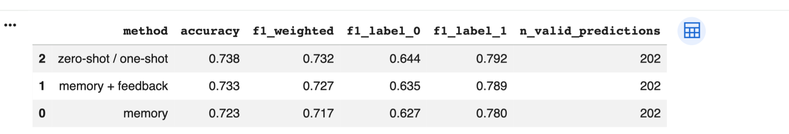
Zero-Shot
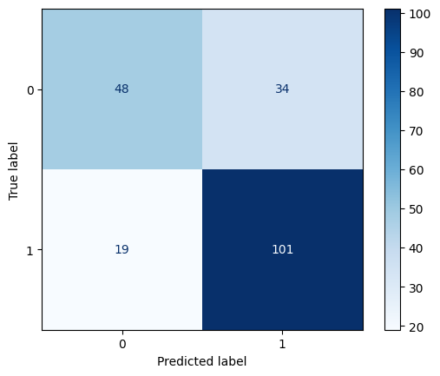

Memory
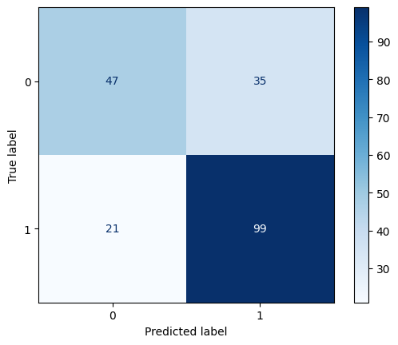
Memory + Feedback
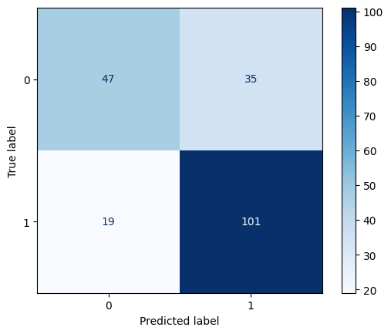
Intercoder Reliability
See RMarkdown in GitHub (Assigment 3 – ICR. RMarkdown).
I calculated intercoder reliability in R, comparing my human classification to the three different LLM models. Overall intercoder reliability appears moderate (Fleiss’ κ = 0.588). However, it is the pairwise agreement amongst LLM models that is high (κ = 0.72–0.82), whereas agreement between the human coding and each LLM is substantially lower (κ ≈ 0.41–0.44). This suggests that the LLMs are internally consistent but only partially capture the human judgment I did with my coding.
Evaluating the Results
The biggest discrepancy I noticed in the results was the difficulty in predicting 0s versus predicting 1s. While the accuracy rate on predicting “dependence” was around 84% (101/120), the accuracy rate on predicting “no dependence” averaged closer to 57% (47/82). In other words, the LLM models (relying upon my codebook) are generating significant false positives (35, Type I error) but relatively fewer false negatives (19, Type II error). The LLMS models are ultimately overpredicting dependence language in the universities when compared to my own human coding.
- How difficult or easy was the task? What problems did you run into? What would you change in your codebook to improve it? What other lessons did you learn from this exercise?
Relatively speaking, this was an easy task. The Google Colab code ran well once I adjusted the API key and inserted my datafile. I did have to write code at the end to export the LLM predictions a separate excel file, because I wanted to have this file on hand.
Looking at the discrepancies between the LLMs and the human coding (as seen in llm_all_predictions.xlsx – highlighted in red), many of them occurred with the University of Toronto sample. Some paragraphs that I coded as being low in dependence, since they reference the government (often the federal government as an alternative funding source) are labelled as high in dependence by the LLMs. I think I need to re-write my codebook to be clearer that dependence language does not necessarily always involve a discussion about the government. Low dependence has more to do about creativity and ingenuity in acquiring funds beyond typical grants or removing the domestic tuition freeze, which may involve some layer of government or be completely independent of government.
I also wonder if - because I gave criteria for 0s and for 1s in my codebook - that added complication for the LLMs. I should be clearer in specifying 1s only, and everything else will be coded as a 0. This also may speak to while using 3 categories (low, medium and high) may be better.
I will go through each discrepancy and revise my codebook accordingly for Part 2 i).

Part II:
- Once you have validated your training set and the labels produced by LLMs, expand the training set until you have (at least) 150 observations per category. You can use LLMs to label, but you will still need to manually validate the labels produced.

- Using your (validated) training set, fine-tune the encoder-only LLM of your choice.

- Report performance statistics for your fine-tuned model (e.g., accuracy, F1, recall, etc.), as well as the confusion matrix.

- Use your trained model to predict labels on a target corpus.

- Describe the results obtained, and whether they match the expectations you had about the data.

